**ReactNative-FoodDeliveryApp Set Up**

**Setup instructions**

**1. Clone app về**

**# Clone the app**

**git clone https://github.com/nhuphaNn1602/ReactNative-FoodDeliveryApp.git**

**2. Tải các phụ thuộc**

**# navigate to app directory, install npm packages**

**cd FoodDeliveryApp**

**npm install**

* **Cho ios:  cd ios**

**# Run the following commands to install the dependencies using bundler, this command will install the necessary Ruby gems specified in the Gemfile**

**bundle install**

**```sh**

**# Next, execute the CocoaPods installation command**

**bundle exec pod install**

**```**

* **Cho android: You can refer to the official React Native documentation for detailed instructions on setting up the Android development environment:**[**https://reactnative.dev/docs/environment-setup**](https://reactnative.dev/docs/environment-setup)

**3. Cài đặt backend:**

**Cài mongoDB:**<https://www.youtube.com/watch?v=gcbMx8owYTg>

(Coi video trên link. Nên chú ý terminal đang ở bash hay zsh. Bash thì vi ~/.bashrc, Zsh thì vi ~/.zshrc)

**Tiếp theo**

* Lấy địa chỉ ip [localhost](http://localhost) hiện tại:

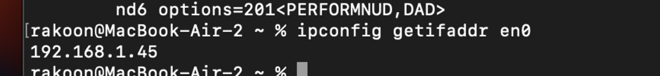

* thay [localhost](http://localhost) bằng địa chỉ ip ở package.json bên backend

* Bên thay bên package.json bên app

* Bên mongodb tạo database foodDelivery_db với colection là users

* Thêm indexA screenshot of a computer

  Description automatically generated

* tạo collection restaurants

* import data

* Tạo collection “carts”

* tạo collection “bookmarks”

* tạo collection “foods”

* import data foods:

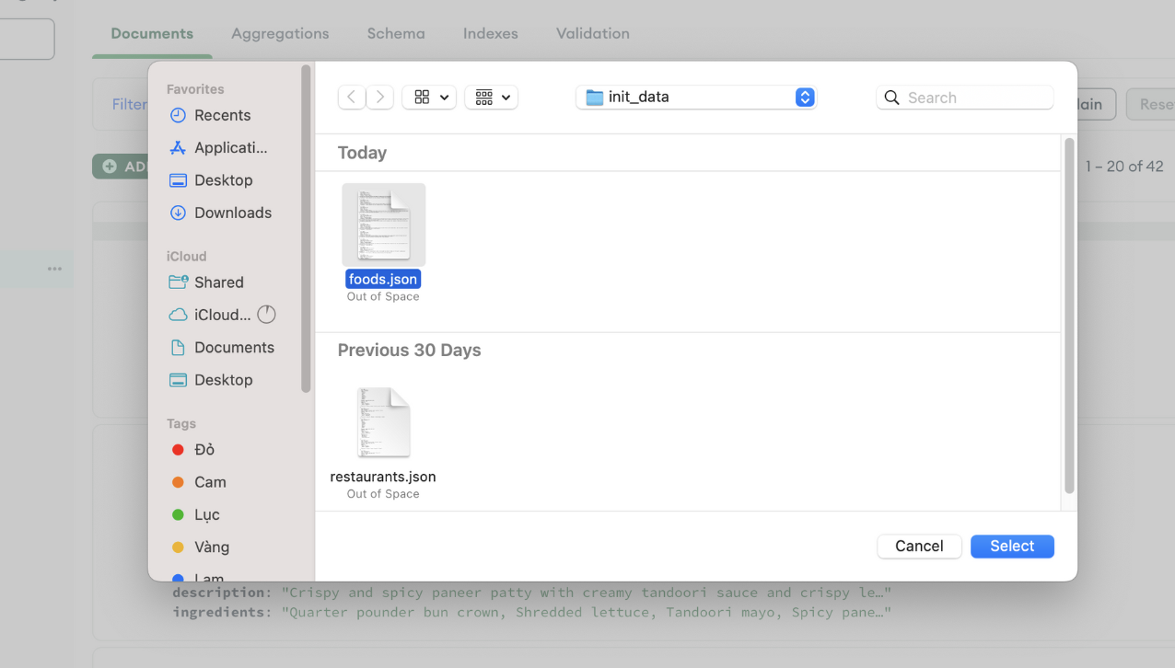

**Để chạy bên backend:**

* **npm install**
* **npm start**

**4. Chạy ứng dụng**

* **# navigate to app directory, build on ios**

**npx react-native run-ios or npm run ios**

* **# navigate to app directory, build on android**

**npx react-native run-android or npm run android**